|  |  |
| --- | --- |
|  | **eMediShop** |
|  | Chandan Healthcare Ltd.  IT Department |

|  |
| --- |
| **[Pharmacy Management System]** |
| eMediShop Application of Point of Sale (PoS) in Pharmacy Retail Stores relevant information |

Contents

About eMediShop 3

Inventory 4

Receiving 6

Transfer 7

Goods Return 8

Zero Stock Purchase Order 10

Health Card Help 11

Password Reset 12

Sales 12

General Sales 12

Generic Product Help 12

Sales of Order 13

Help 14

Hold Bill 14

Audit 15

Short Extra (06/04/17) 15

# About eMediShop

eMediShop™ Point of Sale software solution is designed to meet the demands of pharmacy chain of stores. It is the solution for pharmacy retail business ensuring minimum operational expense and maximum profitability. Empower your retail business with easy-to-use software for tracking sales, inventory or customer information and make pharmacy retail business simple.

This application provides centralize control for the following to reduce the erroneous data entry:

* Product Management
* Vendor Management
* Manufacturer Management
* Purchase of Product
* Accounting System

Sales and Stock Management System is localised.

**Main Screen (eMediShop Application)**

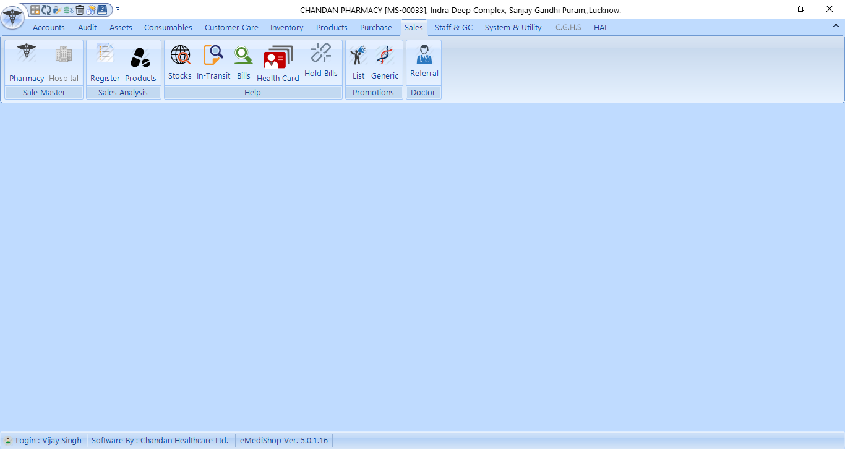

# Tax Calculation

### Sales

In case of pharmacy sales, the following attribute is calculated as:

Amount: MRP x Quantity;

Discount: (MRP x Discount Percentage) x Quantity;

Sale Value/ Taxable Value: Amount - Discount;

The tax calculation will be on Sale Value. The formula to calculate the tax is given below:

*Taxable Value=Sale Value/(1+Tax Rate/100)*

*Tax=Sale Value-Taxable Value;*

*Note: in case of tax changes the sale will always be calculated with new tax policy.*

### Purchase

There are 2 type of tax calculation on purchase invoice:

1. Net Purchase

Tax=(Trade Rate* Quantity) - (((Trade Rate* Quantity) * 100) / ((100 +Tax Rate)))

1. Trade Purchase

Tax=(Purchase Amount-Discount) * Tax Rate/ 100

*Operation Margin: sale value – purchase value;*

Note : at the time of Posting the bill the list of checked by or purchased by will be the list of employee posted on unit and it will be reflect without adding the employee.

# Inventory

This tab have several option to manage Stock/Inventory of Retail Store.

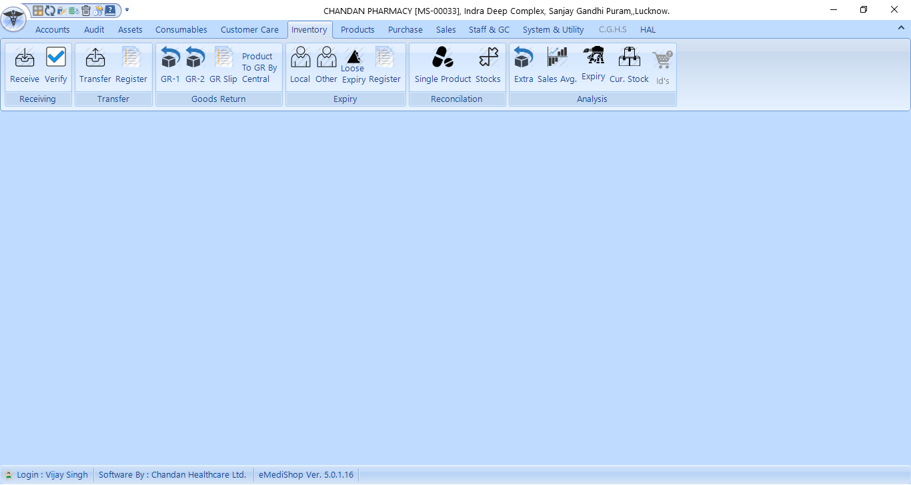

### Receiving

Stocks transfer from warehouse, Other Units and via local purchase will be received in stock from this option. All the transfer id’s will be under the name of unit from they have been transferred. The local purchase bills will be under local purchase.

#### Receive

This option will show you following screen:  
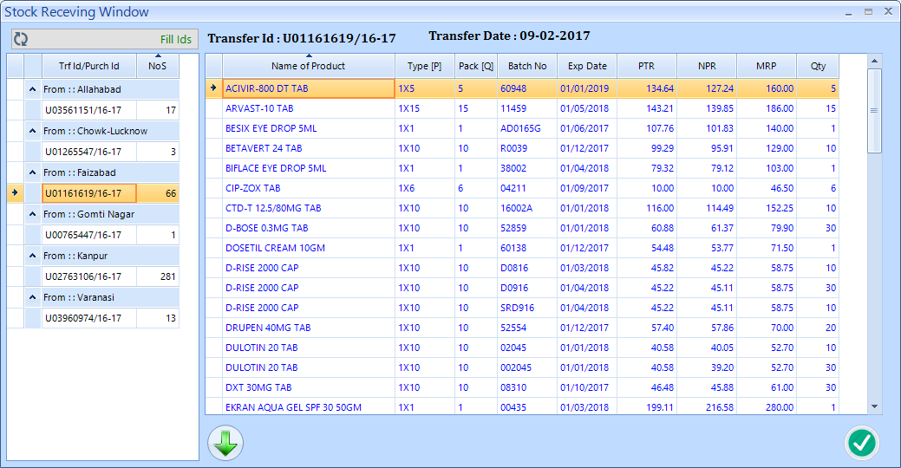

First step to click fill id button to fill the ids, after that you double click on transfer id no, it will show the information right side, match it with transfer paper and click green down arrow to receive into stock.

#### Verify

The stock received at unit can be verified from this screen. You need to select the date and hit submit button to see the detail transfer id wise with amount calculated on npr.

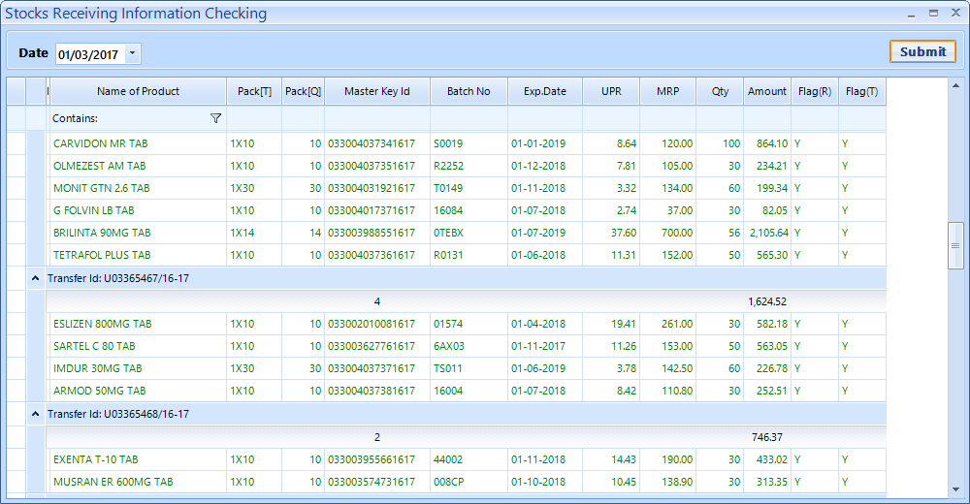

## Transfer

This option used to transfer stock to other units/warehouse. The quantity can’t be transfer in loose. Click >> button to fill the units name, after that you select a unit and start transferring the product. Transfer of first product will assign you a transfer id no which will show with the unit name. due to security reason one transfer id will be open for same unit. The transfer will be completed by hitting “Complete Stock Transfer” button.

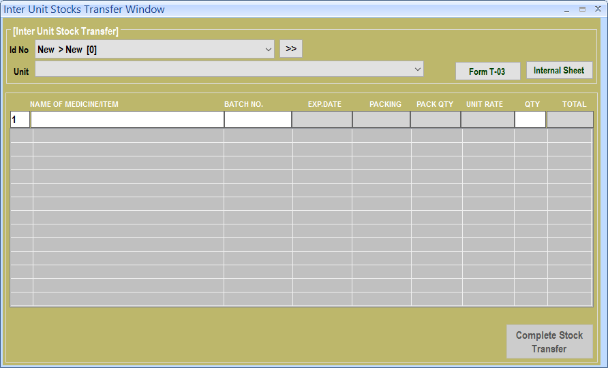

## Goods Return

There are several option regarding return of stock to vendor. It can be wrong purchase, extra purchase, return due to short expiry.

#### GR-1

This option will select the product and return to the vendor from where it was purchased.

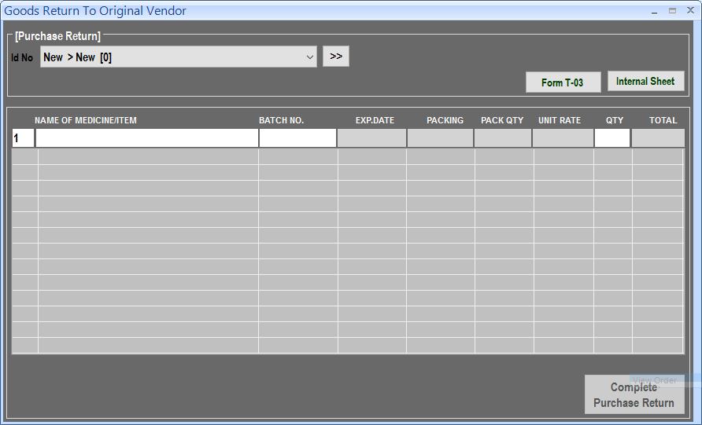

#### GR-2

This option will select the product and return to a manually selected vendor.

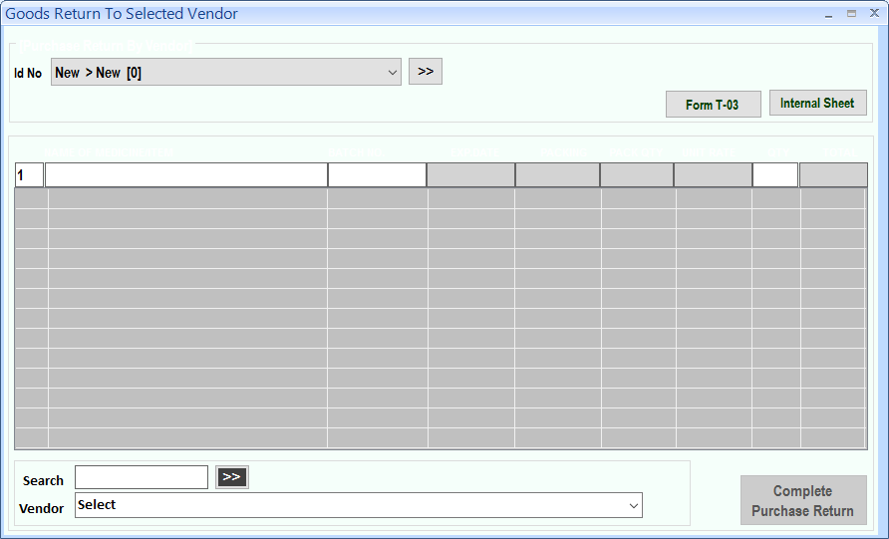

#### Goods Return Slip

This option will print the Goods Return Slip according to Vendor against a selected GR No.

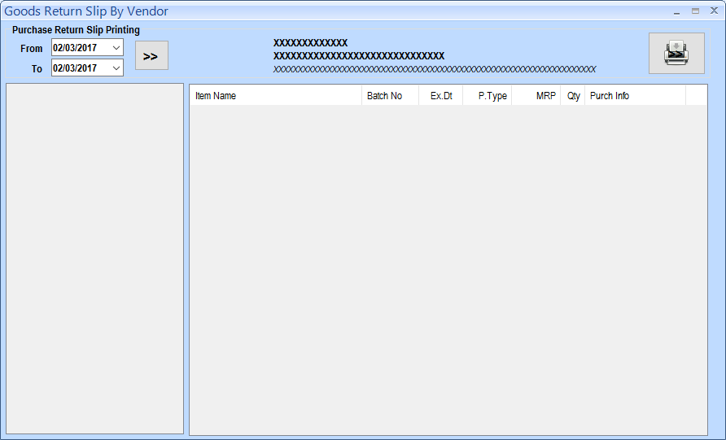

#### Product To GR From Central

This option will show you the product which has been analysed by central team and found that these product should be return. You have to generate the goods return by above GR-1 or GR-2 option and put GR no against the product showing in this report and hit return to update against the product, you can also give any remark against it.

Feeding of GR no and Remark is very simple just double click on it and type the information and Hit return to save.

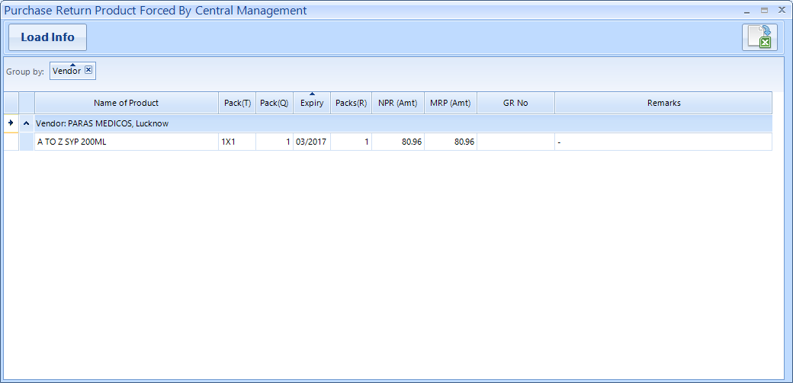

## Zero Stock Purchase Order

This order generated on the basis of stocks. if stocks are 0 according to above parameter (between 2 dates) will generate an order for zero stocks.

The dates always work on last sale date of the product. Last sale date is updated when data transfer on central server. NPR comes from a processed table which schedule is in night. The failure of result is required to check following steps.

1. Schedule process completed.
2. Last sale date updated in unit items table.
3. Unit and central server product reconciled.

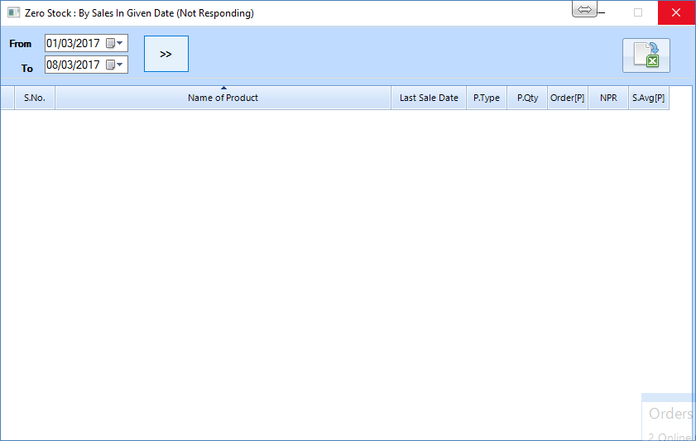

This option available under Purchase ->0 Stocks.

## Extra

Extra product process centrally after that unit will import the extra information and process the file at unit level.

If there will be any mismatch of records the transfer button will not be open.

Note: If unit name showing Red means a Transfer ID is already open for the unit for which you are making extra.

## Health Card Help

In the sale form after pressing F1 you opt Health Card Help widow. This window is now bar code searching enabled show you have to type the information and hit return to fill the customer information.

You can also import and update card from here Now by clicking Health Card Check Box.

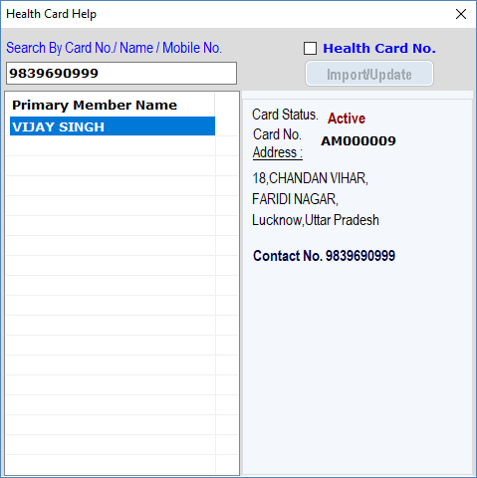

From the Date **20-11-2017** Card Policy has been changed and the bill will be generated only with the Name of Primary Card Holder, No Faimly Members can use this card if they want bill of their name.

The discount nature of family member will be followed as a new card policy. The healthcard coupon generated after purchasing of 10000 will be availed by the primary Card Holder.

## Password Reset

The password will be forced to change on daily basis. Last password will not be valid as current password.

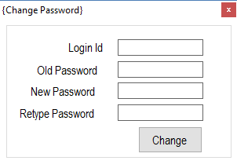

# Sales

## General Sales

## Generic Product Help

The product those are generic will show along with the branded on the basis of margin in product in generic segment.

Generic product will be searched form left side.

All the generic name is available with its constituents as first e.g.

The highest margin product will be first of matched product.

|  |  |  |  |  |  |
| --- | --- | --- | --- | --- | --- |
| **item_id** | **Item_Name** | **saltnames** | **pack_type** | **pack_qty** | **margin** |
| CP14448 | CALPOL PAEDIATRIC DROPS 15ML | Paracetamol 100 mg | 1X1 | 1 | 50.6435 |
| CP43220 | GALPARA DROP 50ML | Paracetamol 100 mg | 1x1 | 1 | 0 |
|  |  |  |  |  |  |

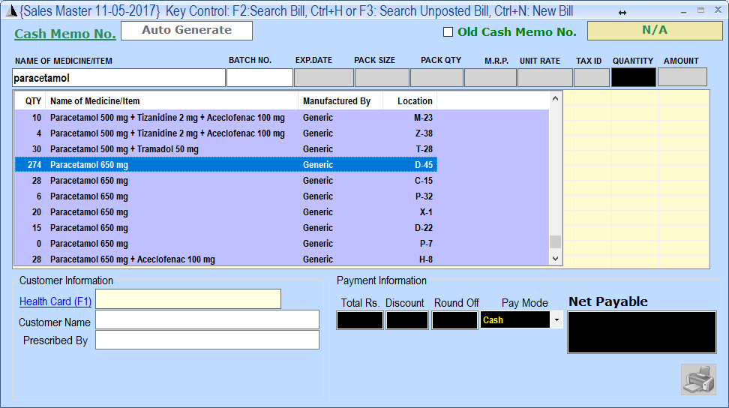

Note : Monthly Generac Product Table should be updated.

## Sales of Order

Release on 04-04-2017

This process used to generate the receipt of sale of orders those has been pushed by tele caller’s. The concept has been changed:

1. Now you can process the sales of orders those are for promotional days but you will complete the sales on order date only.
2. You can print internal paper to pick the medicine.
3. Hold invoice you will see in red color.
4. Without marking you will see all the order except promotional days.
5. With marking you will see the order of 1st and 15th only.

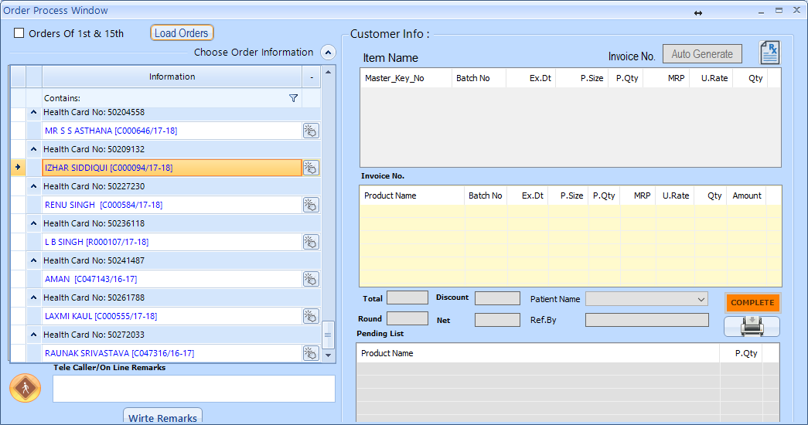

## Trading

This option will be used when you are transferring product to interstate or intercompany. It will work same as other stock transfer but the id’s will be generated with the starting of “S” letter.

## Help

### Hold Bill

In this option you can see the unresolved id of Transfer, Sales and purchase. You can delete the non-required ids.

s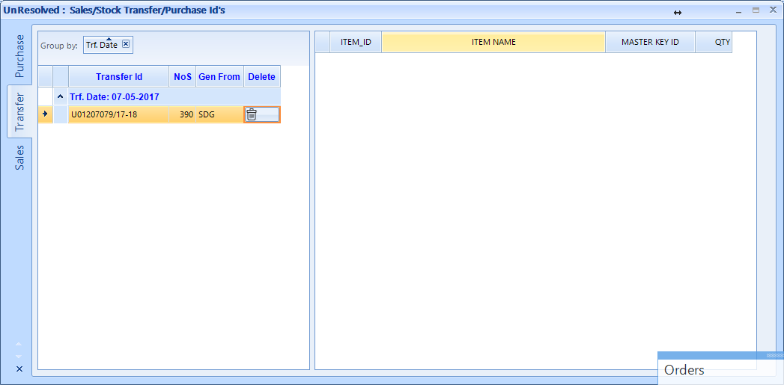

## Sale Register

Sales Register can be shown between dates. Red entries are sales return entries. Here you can change the referral name.

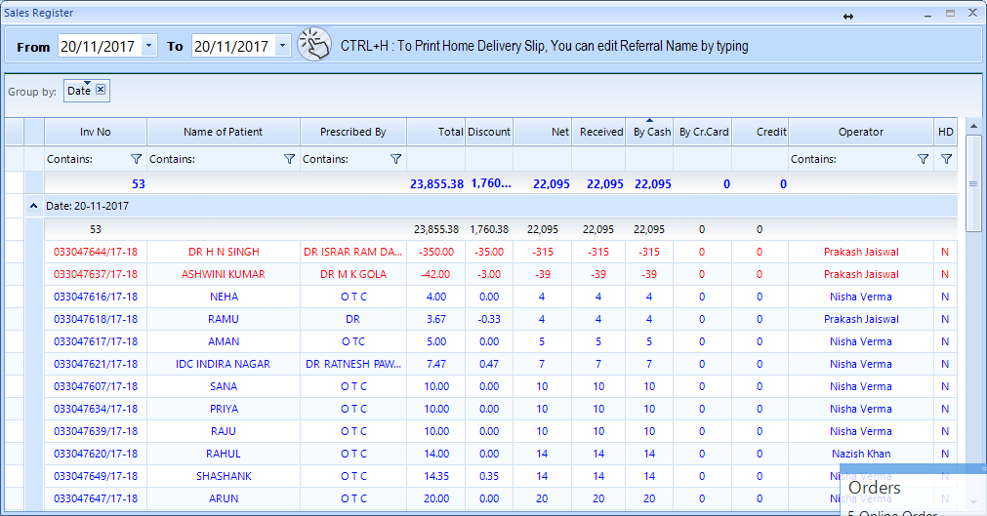

# Audit

## Short Extra (06/04/17)

The short and extra generated during the audit will be transfer to Central Server For processing after processing extra product will be imported at unit.

Generation of excel concept has been changed due to not accepting the old method of excel conversion.

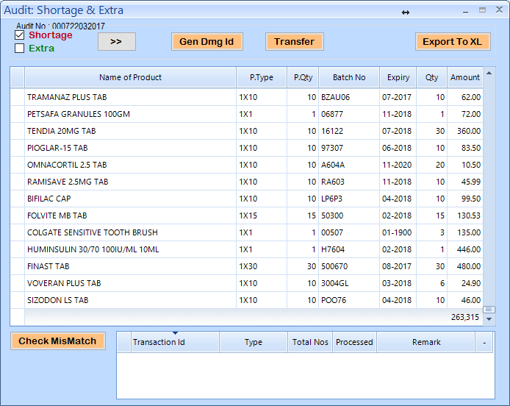

Total of Shortage is given at the end of Grid. As Rs. 263315.

## Extra product (batch not found in system)

The product those are extra because of batch no not exists in the system will be feed in purchase and this will not be posted there. Trade rate will be last and MRP should be matched.

The purchase id will be processed in Audit section under “Extra In (By Purchase)”.

**Step 1 :** Put purchase id number and press return / enter button. The grid will be populated with the records.

**Step 2 :** Check the records.

**Step 3 :** Click Process button. (pXtraInByPurchaseid [eMediCentral])

It will generate a transfer id which you have to import.

# Product

In this option you have miscellaneous option about Products update.

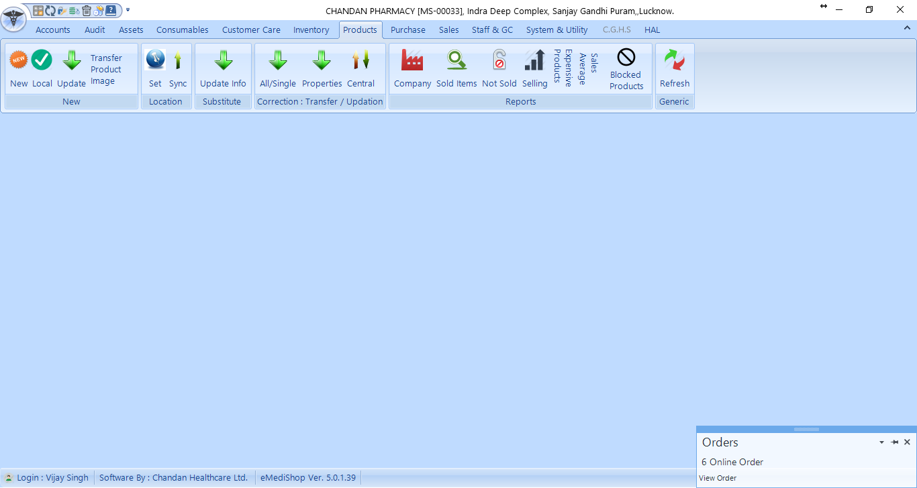

## New

The product those are not available at Centre are New. There is a process to handle the New product.

### New

Store new Product name in system. Always put 1 Unit in case of No Order of Product to maintain the range.

### Local

Mark local product by marking tick against the product. Local Product will not be transfer to warehouse.

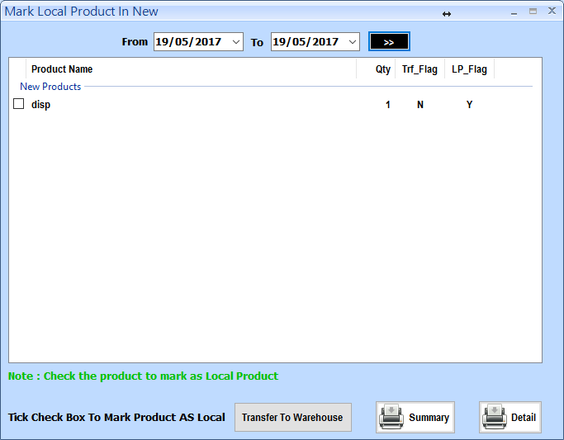

Click Transfer to warehouse button to transfer product to warehouse those are not marked as Local.

### Update

This option used to update the new product name with product available at Central Server with their Item Code. This work reduced the work of Warehouse.

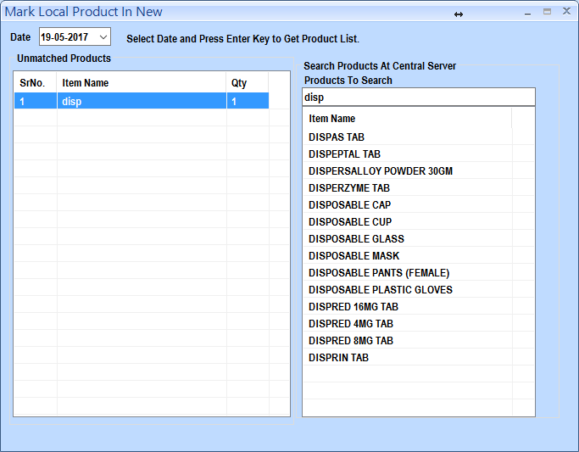

## Correction: Transfer & Updation

### ALL/Single

Update product Information from Central Database and also you can update single.

### Properties

Correction of properties of product like expiry,NPR, MRP, Batch No will be transfer from here to Central office.

In case of auto failure of key updating you can manually update the information of master key from here.

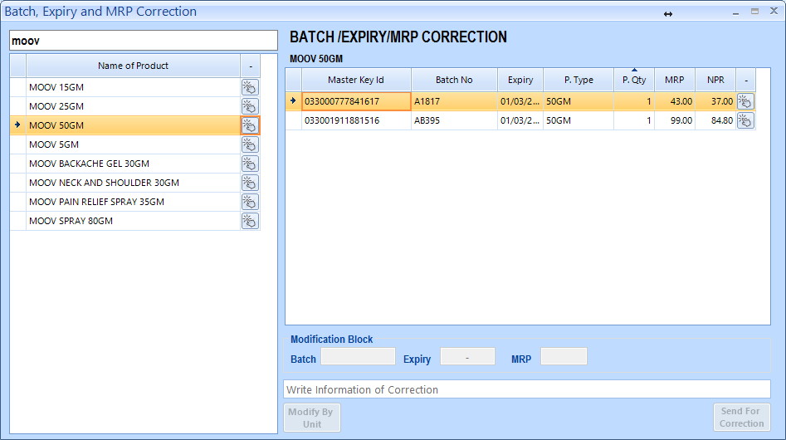

### Transfer Product Image

The new product image to be transferred by this option which will be shown by warehouse people.

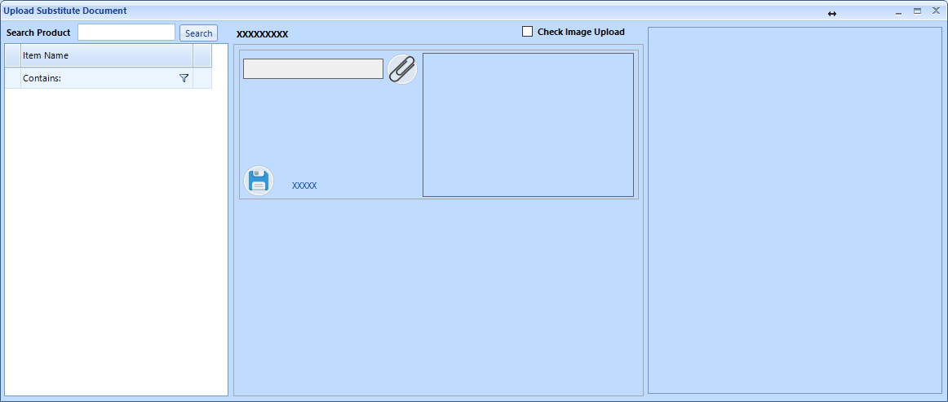

## Generic

This option is provide the bulk updating of Salt Information and also Single Salt Updating.

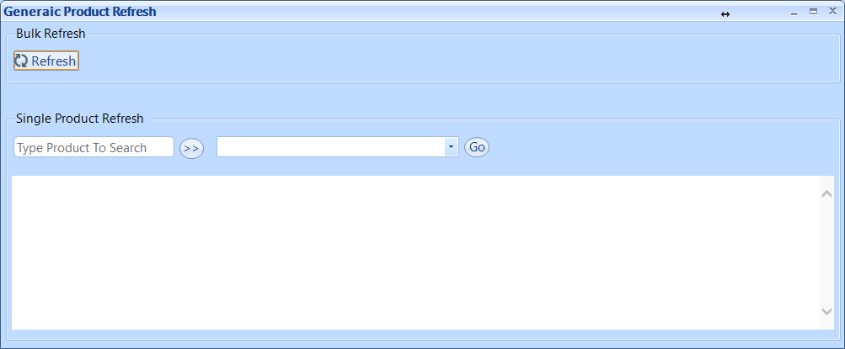

**For Bulk Refresh:** Just Click Refresh button in Bulk Refresh Group.

**For Single Refresh:** in Single Product Refresh type name of product and click double arrow button, the searched information will be filled in next combo where you have to select the desired product and press GO button to add the salt information of the selected product if available at central server.

# Customer Care

## Bulk Update

This option will update all cards used in last one year at your unit. This will speed up your searching.

Just click on the button and select Y if you want to do it.

## 

## GST Implementation

**eMediShop**

TaxConfig

Add state_id in masterkey_info

Add fields in sale_items as pp_id,ps_id

**eMediCentral**

fnCalculateTaxGST()

Add state_id in masterkey_info

Purchase_insert